RIAD LALLABAYA
Discoveries and Getaways
Excursions and Transfers
from Riad Lallabaya in Marrakech

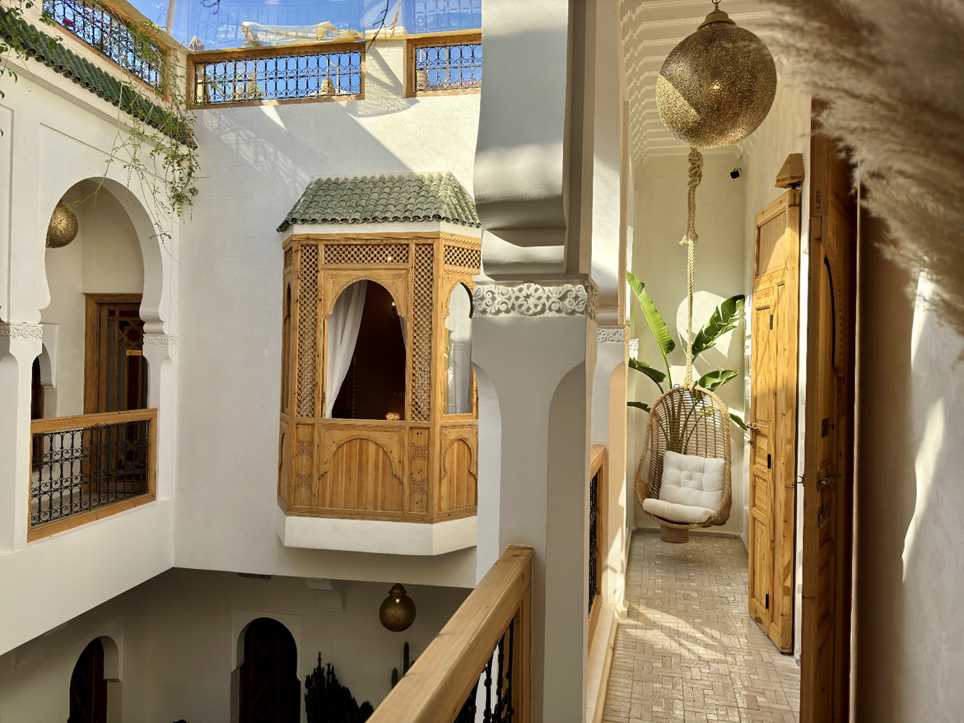

VALLEE DE L’OURIKA

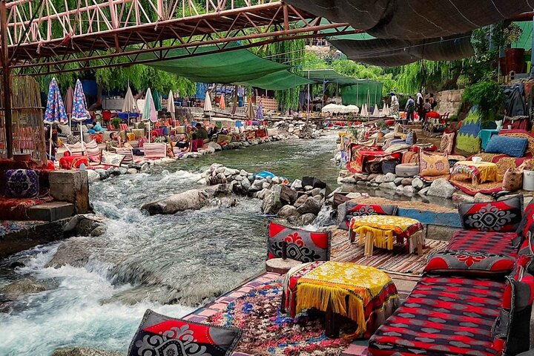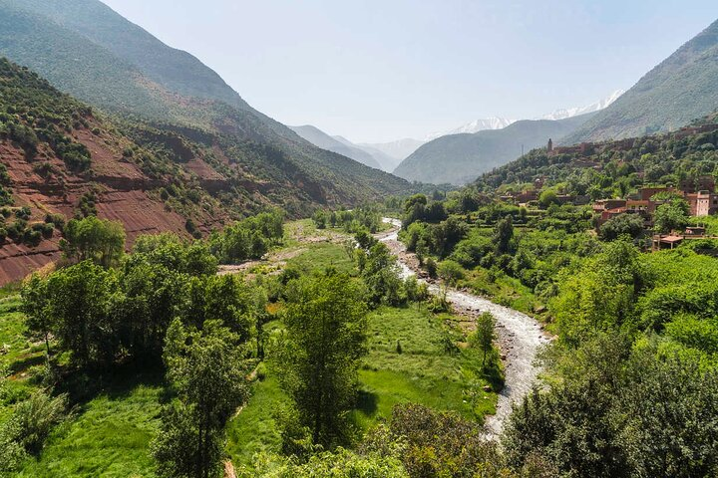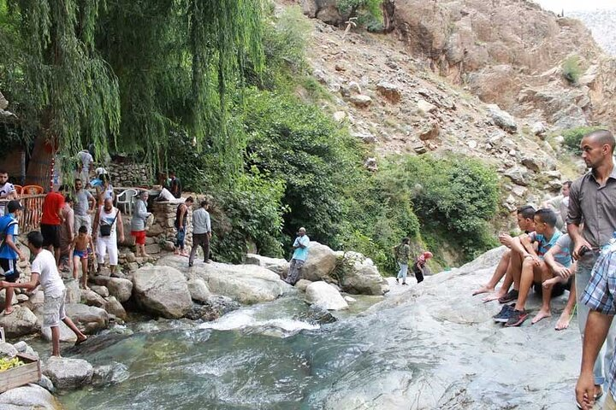

Ourika Valley: Nature and Culture Escape
Departure Time: 8:00 AM - Return Time: 5:30 PM (approx.)

Set off on a private excursion from Marrakech to explore the stunning Ourika Valley, located at the foothills of the Atlas Mountains. This picturesque valley is renowned for its lush landscapes, traditional Berber villages, and the famous Setti Fatma Waterfalls. This tour offers a perfect blend of nature, adventure, and Berber culture.

Day Itinerary:

8:00 AM - Departure from Riad Lallabaya

9:00 AM - Tnine Ourika, Souss-Massa
Your first stop will be a visit to the traditional Berber (or Amazigh) villages, where you’ll immerse yourself in their unique culture and way of life. These traditional communities provide insight into the centuries-old lifestyles of Morocco’s indigenous populations. As you explore, you’ll admire their distinctive architecture, observe artisans at work, and possibly visit the lively weekly souk (market) held on Mondays or Thursdays.

10:00 AM - Ourika, Marrakech-Safi
Visiting the women’s argan cooperative offers a unique opportunity to witness sustainable practices and the empowerment of local women in Morocco. Here, you’ll learn how argan nuts are harvested and processed, gaining insight into traditional methods passed down through generations.

11:00 AM - Aghbalou, Marrakech-Safi
At the Berber house, you’ll delve into the rich cultural heritage of the Berber people. This visit allows you to explore a traditional family home and discover the unique aspects of their daily life. Walking through the house, you’ll notice the traditional décor that reflects the history and values of Berber culture. Conversations with the family provide an understanding of their routines, customs, and the deep sense of community within Berber society.

12:00 PM - Setti Fatma, Marrakech-Safi
Upon arriving in Setti Fatma, you will be greeted by your local guide, who will lead you on an invigorating hike to the nearby waterfalls of the Ourika Valley. This trek offers an opportunity to connect with nature while enjoying breathtaking views of the valley, making for a memorable and immersive experience.

1:30 PM - Ourika Valley, Morocco
Savor a traditional Berber lunch at a local restaurant in the Ourika Valley by the riverside. This is the perfect opportunity to relax, enjoy the fresh flavors of Moroccan cuisine, and take in the vibrant and picturesque scenery around you. Typical dishes include tagines, couscous, and fresh seasonal vegetables. (not included)

3:00 PM - Return to Marrakech
After lunch, begin your return journey to Marrakech, taking in the final scenic views of the valley and the Atlas Mountains.

5:30 PM - Arrival at Riad Lallabaya

Excursion Highlights:

- Private and personalized experience with a dedicated guide (optional).
- Exploration of traditional Berber villages and insight into their way of life.
- Visit to a women’s argan cooperative showcasing sustainable practices.
- Cultural immersion at a traditional Berber family home.
- Guided hike to the breathtaking Setti Fatma Waterfalls.
- Traditional Berber lunch by the riverside amidst stunning landscapes.

Practical Information:

- Price per person: Please refer to the price list
- Transportation included: Private, air-conditioned vehicle with pickup and drop-off at Riad Lallabaya
- Guide (optional 250 Mad): A private guide for the day can be arranged for an additional fee.
- What to bring: Comfortable walking shoes, a hat, sunscreen, and a camera to capture the beauty of the Ourika Valley.
- Lunch and tips are not included in the price and must be paid directly on-site.

Book your private excursion to the Ourika Valley now and experience a perfect combination of nature, culture, and adventure!

ATLAS MOUNTAIN – THE THREE VALLEYS

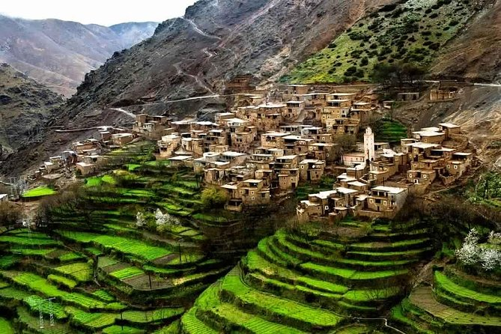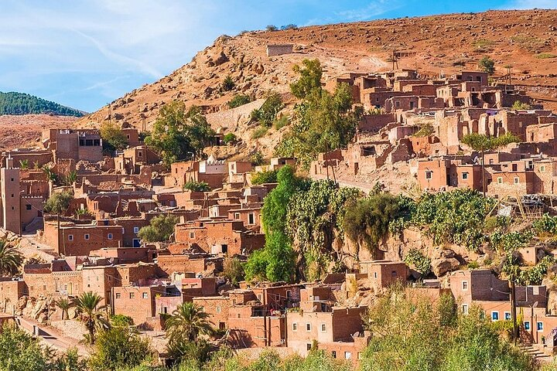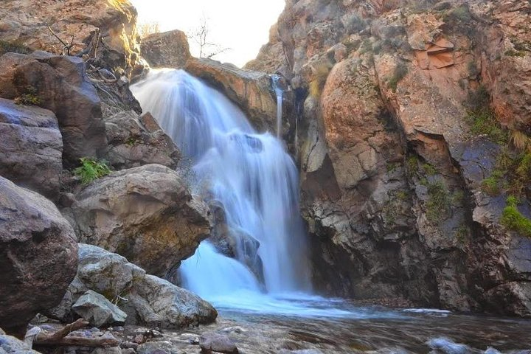

Private Full-Day Excursion to the Three Valleys - A Majestic Adventure
Departure Time: 8:00 AM - Return Time: 5:30 PM (approx.)

Embark on a private excursion from Marrakech to discover the breathtaking Three Valleys, including Lalla Takerkoust, Amizmiz, and Aroumd, nestled at the foothills of the Atlas Mountains. These valleys are renowned for their stunning natural landscapes, traditional Berber villages, and rich culture. This excursion offers a perfect blend of adventure, relaxation, and discovery.

Day Itinerary:

8:00 AM - Private pick-up from Riad Lallabaya

9:00 AM - Arrival at Lalla Takerkoust Lake
Your first stop will be Lalla Takerkoust Lake, a peaceful and picturesque reservoir located just outside Marrakech. Enjoy the serene atmosphere, stroll along the lake's shores, and admire the spectacular views of the Atlas Mountains. It’s the perfect spot to relax and start your day of exploration. On-site, you can also engage in activities such as quad biking, jet skiing, or paddle boating.

10:00 AM - Visit to Amizmiz Village
Continue your journey to the charming village of Amizmiz, a traditional Berber village located at the foothills of the Atlas Mountains. Explore the village and its surroundings while learning about the unique lifestyle of the Berber people. You may also visit a local market (depending on the day), where you’ll find fresh produce, handmade crafts, and other local goods.

12:00 PM - Head to Aroumd Village
Next, head to Aroumd, a village located at an altitude of 1,800 meters in the heart of the Atlas Mountains. Aroumd offers breathtaking views of the surrounding mountains and is the ideal place to experience traditional Berber culture. You can enjoy a short hike from the village to take in panoramic views and the tranquil environment.

1:30 PM - Traditional Berber Lunch in Aroumd
For lunch, savor a delicious traditional Berber meal at a local restaurant in Aroumd. Relish a hearty tagine or couscous, prepared with fresh, locally sourced ingredients. (Lunch is not included in the price and is at your own expense.)

3:00 PM - Free time to explore or relax
After lunch, enjoy free time to further explore the village of Aroumd, visit local markets, or simply relax and breathe in the fresh mountain air.

4:00 PM - Return to Marrakech
As the day comes to an end, begin your journey back to Marrakech, taking in the last glimpses of the Atlas Mountains and surrounding valleys.

5:30 PM - Arrival at Riad Lallabaya

Excursion Highlights:

- Private and personalized experience with a dedicated guide (optional).
- Visit to Lalla Takerkoust Lake, a serene reservoir with spectacular views.
- Exploration of Amizmiz, a traditional Berber village at the foot of the Atlas Mountains.
- Discover Aroumd, a mountain village offering breathtaking views and an insight into Berber culture.
- Traditional Berber lunch at a local restaurant in Aroumd.
- Panoramic views of the Atlas Mountains and lush valleys.

Practical Information:

    - Price per person: Please refer to the price list
    - Transportation included : Private, air-conditioned vehicle with pickup and drop-off at Riad Lallabaya
    - Guide (optional 250 Mad) : A private guide for the day can be arranged for an additional fee.
    - What to bring : Comfortable walking shoes, a hat, sunscreen, a camera, and a light jacket (temperatures in the mountains may be cooler).
    - Lunch and tips are not included in the price and must be paid directly on-site.

Book your private excursion to the Three Valleys now and enjoy an unforgettable day exploring the natural beauty and Berber culture in the heart of the Atlas Mountains!

DESERT D’AGAFAY

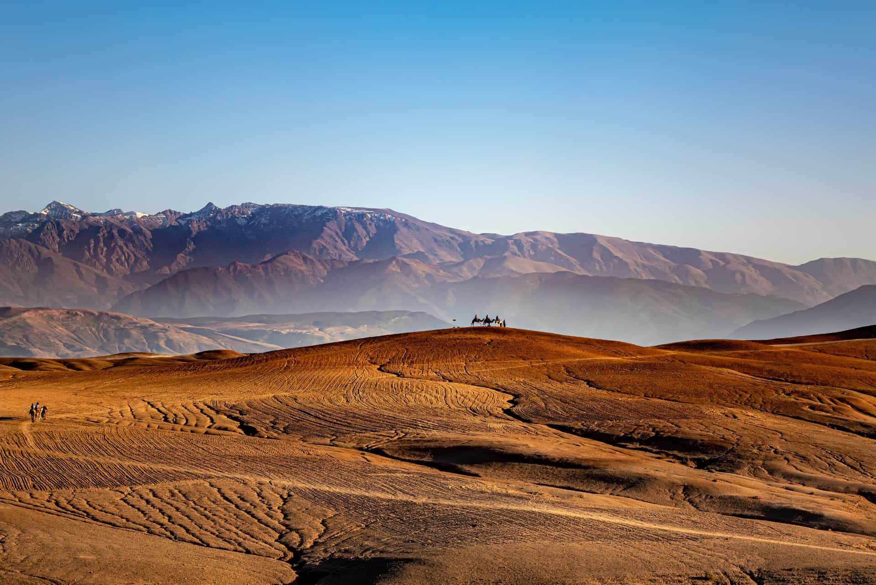

Private Half-Day Excursion to the Agafay Desert - A Scenic Escape
Duration: Half-day
Departure Time: 9:00 AM or 2:00 PM – Return Time: 1:00 PM or 6:00 PM (approx..)

Embark on a private half-day excursion to the stunning Agafay Desert, located just 40 km south of Marrakech. The Agafay Desert is a true haven of peace with sublime landscapes. While it may not be a part of the Sahara, this rocky desert offers a unique and magical experience reminiscent of its sandy counterpart. Exploring the Agafay Desert will leave you with unforgettable memories—just follow the guide to learn more about this fantastic place!

When we think of deserts and the Sahara, images of fine sand dunes often come to mind. However, the Agafay Desert offers an entirely different kind of scenery. In this vast expanse south of Marrakech, you’ll find rocky hills in light tones, creating a serene and breathtaking atmosphere.

Day Itinerary:

9:00 AM / 2:00 PM - Private pick-up from Riad Lallabaya

10:00 AM - Arrival at the Agafay Desert
After a short drive from Marrakech, you’ll arrive in the Agafay Desert. Admire its unique rocky and golden terrain, a perfect backdrop for quiet reflection or exciting activities.

10:30 AM - Camel Ride Experience (optional)
Take a short camel ride through the desert for a quintessential Moroccan adventure. Let the peaceful atmosphere and panoramic views create lasting memories.
Or
10:30 PM - Quad Biking or Buggy Adventure (optional)
For those seeking more excitement, you can opt for a thrilling quad biking or buggy ride. Explore the rugged terrain and enjoy a burst of adrenaline as you navigate the rocky trails. (Activity not included in the price; can be arranged upon request.)

11:00 AM - Free Time to Explore or Relax
Stroll through the desert, capture stunning photos, or simply enjoy the peaceful ambiance. For those seeking an adrenaline rush, quad biking or buggy rides can be arranged on-site. (Optional activities not included in the price.)

12:00 PM - Return to Marrakech
1:00 PM / 6:00 PM - Arrival at Riad Lallabaya

Excursion Highlights:

- Private and personalized half-day experience.
- Stunning views of the Agafay Desert’s "stone desert" terrain.
- Optional camel ride for a traditional touch of adventure.
- Opportunities for optional activities such as quad biking or buggy rides.
- Perfect for those with limited time, offering a short yet memorable desert escape.

Practical Information:

- Price per person: Please refer to the price list
- Transportation included: Private, air-conditioned vehicle with pickup and drop-off at Riad Lallabaya
- Camel 1 hour (optional mad? pp): camel ride can be arranged for an additional fee.
- Quad1 hour (optional mad? pp): quad biking or buggy ride can be arranged for an additional fee.
- What to bring: Comfortable clothing, sturdy walking shoes, sunglasses, sunscreen, and a camera to capture the scenery.
- Meals, tips, and optional activities: Not included in the price and must be paid directly on-site.

Book your private half-day excursion to the Agafay Desert now for a quick yet unforgettable escape into nature’s beauty, just minutes from Marrakech

OUZOUD WATERFALLS

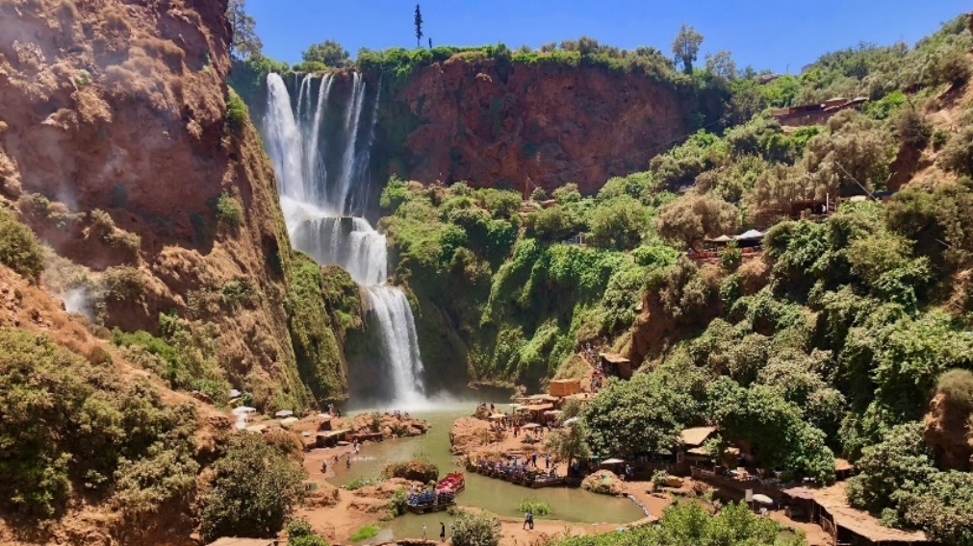

Private Full-Day Excursion to Ouzoud Waterfalls - A Majestic Natural Wonder
Departure Time: 7:00 AM - Return Time: 6:00 PM (approx.)

Discover one of Morocco's most impressive natural wonders on a private excursion to the Ouzoud Waterfalls, located in the High Atlas Mountains. This fully personalized experience allows you to immerse yourself in nature, marvel at the 110-meter-high cascades surrounded by lush vegetation and local wildlife. A perfect blend of nature, culture, and Adventure !

Day Itinerary:

7:00 AM - Private pick-up from Riad Lallabaya

9:30 AM - Arrival at Ouzoud Waterfalls
After approximately 2.5 hours of driving, you will arrive at the Ouzoud Waterfalls. These falls are among the most spectacular in North Africa. Your private guide will introduce you to the area, explaining the geological formations and the local flora and fauna.

10:00 AM - Exploring the Waterfalls
Take your time to explore the surroundings of the falls. Hike along the scenic trails, admire the roaring cascades, and enjoy panoramic views from various vantage points. You can also venture to the base of the waterfalls for a closer look and spot the monkeys that inhabit the region.

12:00 PM - Lunch at a Restaurant with a View of the Waterfalls
For lunch, savor a traditional Moroccan meal at a local restaurant near the falls, offering breathtaking views of the cascades. Indulge in dishes like tagine, couscous, or grilled meats, served with fresh olives, bread, and seasonal fruits. (Lunch is not included in the price and is at your own expense.)

1:30 PM - Free Time to Explore or Relax
After lunch, enjoy some free time to further explore the area. You can take a boat ride near the base of the falls, relax by the river, or stroll through the olive groves surrounding the waterfalls.

3:00 PM - Visit to Nearby Berber Villages
Before heading back, your guide will take you to visit nearby Berber villages. Discover traditional Berber architecture, learn about their culture, and possibly interact with local residents.

4:00 PM - Return to Marrakech
Begin your journey back to Marrakech, taking in the beautiful Moroccan countryside along the way.

6:00 PM - Arrival at Riad Lallabaya

Excursion Highlights:

- Private and personalized experience with a dedicated guide.
- Discover the Ouzoud Waterfalls, one of Morocco’s most famous natural landmarks.
- Scenic hikes, panoramic views, and wildlife observation, including monkeys.
- Traditional Moroccan lunch with a view of the waterfalls.
- Free time for boat rides, relaxing by the river, or exploring olive groves.

Practical Information:

- Price per person: Please refer to the price list
- Transportation included: Private, air-conditioned vehicle with pickup and drop-off at Riad Lallabaya
- Guide (optional 250 mad): A private guide for the day can be arranged for an additional fee.
- What to bring: Comfortable walking shoes, a hat, sunscreen, and a camera to capture the beauty of the falls.
- Lunch and tips: Not included in the price and must be paid directly on-site.

Book your private excursion to Ouzoud Waterfalls now and enjoy a relaxing and adventurous day at one of Morocco’s most stunning natural sites!

ESSAOUIRA CITY
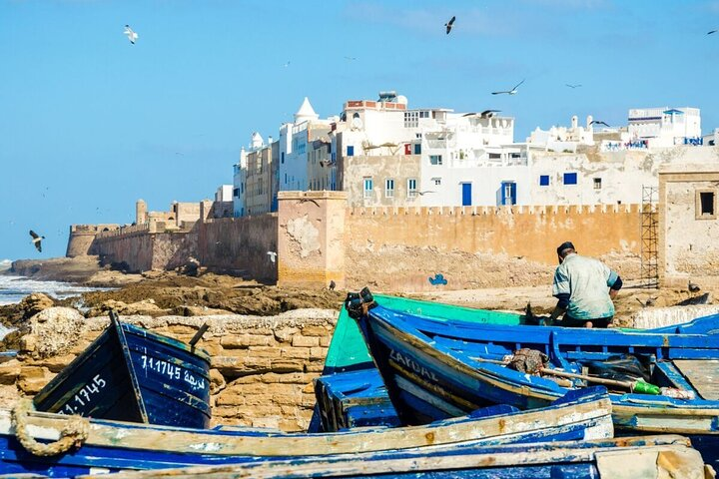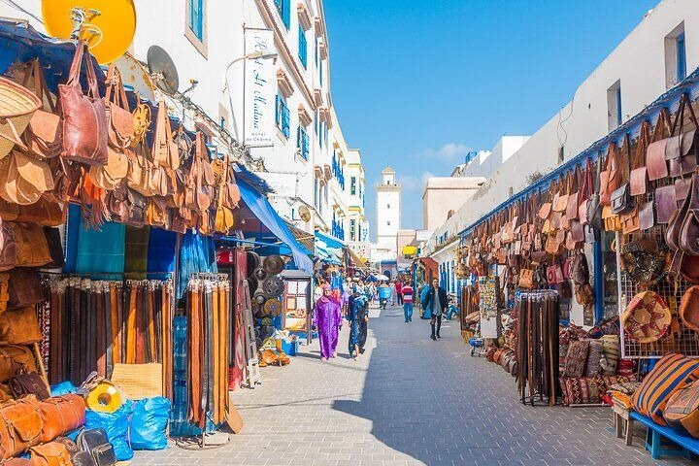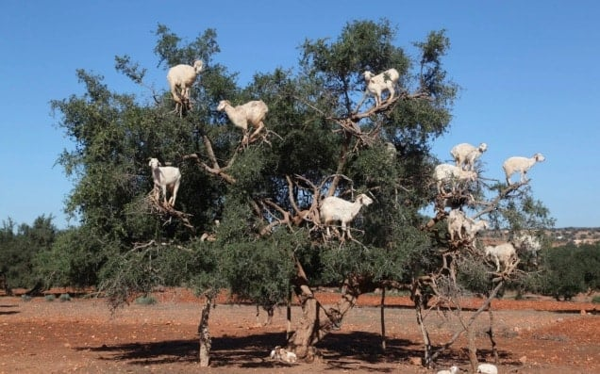

Private Full-Day Excursion to Essaouira - A Coastal Gem
Departure Time: 7:30 AM - Return Time: 6:30 PM (approx.)
Escape to the charming coastal town of Essaouira, a UNESCO World Heritage Site, on a private excursion from Marrakech. Known for its laid-back atmosphere, beaches, and vibrant medina, Essaouira is the perfect destination for those who wish to explore Morocco’s history and culture by the sea.
Day Itinerary:
7:30 AM - Private pick-up from Riad Lallabaya
9:45 AM
A first stop to admire the famous "goat tree," an astonishing argan tree where goats love to perch!

10:00 AM
Time to visit a Berber women's cooperative producing argan oil, where you can learn more about this magical product and its benefits.

11:00 AM - Arrival in Essaouira
After approximately 2.5 hours on the road, you will arrive in Essaouira, a charming city blending history with a relaxing coastal vibe. Your private guide (optional) will greet you and take you on a tour of the highlights of this historic town.

10:30 AM - Exploration of Essaouira’s Medina
Visit to the medina, a UNESCO World Heritage Site. Stroll through narrow streets lined with blue-and-white buildings, explore its bustling souks, art galleries, and craft shops. Don’t miss a detour to the Skala de la Ville for panoramic views of the ocean and historic ramparts.

11:30 PM - Visit to the Port and Fish Market
Head to the lively fishing port, where you’ll see traditional wooden boats and the local fish market. Watch fishermen unloading their daily catch and take a short walk along the docks.

1:30 PM - Lunch at a Seaside Restaurant
For lunch, enjoy a delicious seafood meal at one of Essaouira’s seaside restaurants. Choose from a variety of freshly caught fish, grilled or prepared in traditional Moroccan styles. (Lunch is not included in the price and is at your own expense.)

2:30 PM - Free time to explore or relax
After lunch, enjoy some free time to explore the city at your own pace. You can visit Essaouira Beach, take a walk along the ramparts, or browse the town’s renowned jewelry and craft workshops.

4:00 PM - Visit to the Jewish Quarter
In the late afternoon, take a walk through the Jewish Quarter (Mellah), a historic area with fascinating buildings and unique architecture. Learn about the influence of the Jewish community on Essaouira’s history and culture.

5:00 PM - Departure for Marrakech
6:30 PM - Arrival at Riad Lallabaya

Excursion Highlights:
• Private and personalized experience with a dedicated guide (optional).
• Exploration of Essaouira’s Medina, a UNESCO World Heritage Site.
• Visit to the lively fishing port and observation of local fishermen.
• Delicious seafood lunch by the seaside.
• Free time to explore the beach, ramparts, and artisan workshops.

Practical Information:
• Price per person: Please refer to the price list
• Transportation included: Private, air-conditioned vehicle with pickup and drop-off at Riad Lallabaya
• Guide (optional 250 mad): A private guide for the day can be arranged for an additional fee.
- What to bring: Comfortable walking shoes, a hat, sunscreen, and a camera to capture Essaouira’s beauty.
- Lunch and tips are not included in the price and must be paid directly on-site.

Book your private excursion to Essaouira now and enjoy a day of relaxation and discovery in one of Morocco’s most beautiful coastal towns!

OUARZAZATE
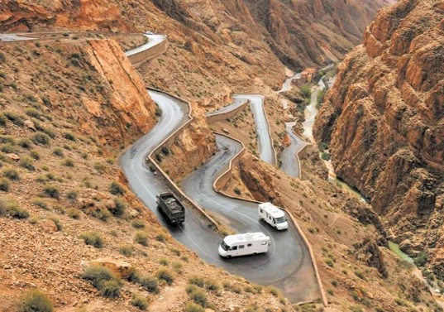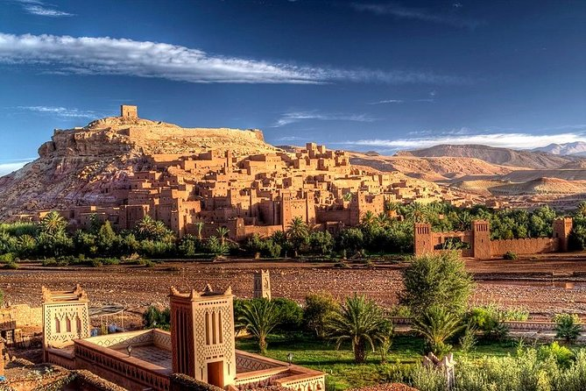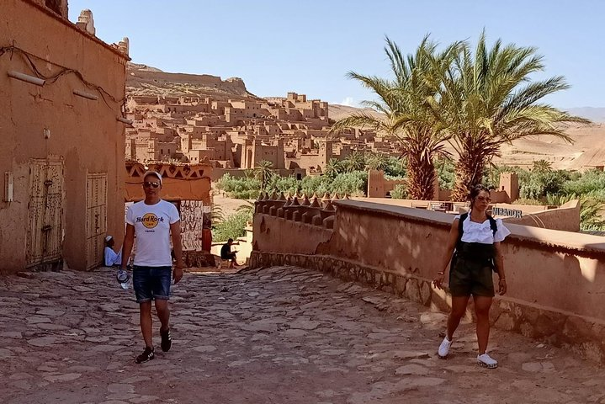

Ouarzazate: Gateway to the Desert
Departure Time: 7:00 AM - Return Time: 7:00 PM (approx.)

Embark on an unforgettable private day trip to Ouarzazate, often called the “Gateway to the Desert.” Renowned for its stunning natural beauty and rich cultural heritage, this southern Moroccan gem lies at the crossroads of the Atlas Mountains and the golden dunes of the Sahara. Founded in the 20th century, Ouarzazate has grown into an essential stop on trade routes linking Marrakech to the Sahara.
This enchanting city captivates visitors from around the globe not only for its breathtaking landscapes but also as a prominent hub of the film industry. The famous Atlas Film Studios have hosted the production of numerous iconic movies. Beyond its cinematic allure, Ouarzazate boasts exceptional historical landmarks such as the Kasbah of Taourirt, an outstanding example of traditional Berber architecture, and Aït Ben Haddou, a UNESCO World Heritage Site.
Day Itinerary :

7:00 AM - Private pickup at Riad Lallabaya
Your journey begins with a private pickup directly at Riad Lallabaya. Travel in comfort in your private, air-conditioned vehicle as you head through the breathtaking landscapes of the High Atlas Mountains. Admire the stunning views of winding roads, picturesque valleys, and traditional Berber villages along the way.

9:30 AM - Stop at Tizi n’Tichka Pass
After about 2.5 hours of driving, pause at the Tizi n’Tichka Pass, one of the highest mountain passes in Morocco. Take a moment to stretch your legs, capture photos of the panoramic views, and marvel at the rugged beauty of the Atlas Mountains.

11:30 AM - Arrival in Ouarzazate and guided exploration
Upon arrival in Ouarzazate, you’ll be greeted by its impressive architecture and the warm hospitality of its people. Visit the Kasbah of Taourirt, a UNESCO World Heritage site, and learn about its fascinating history as a former palace for the Glaoui family. Explore the intricately designed rooms and courtyards that showcase Morocco's rich architectural heritage.

1:00 PM - Lunch (not included)
Enjoy a delicious traditional lunch at a local restaurant (to be paid on-site). Savor Moroccan specialties such as lamb or chicken tagine, couscous, and refreshing mint tea, all while soaking up the charming desert ambiance.

2:30 PM - Visit the Atlas Film Studios
Dive into the cinematic world at the famous Atlas Film Studios, where many Hollywood blockbusters and international films were shot, including Gladiator, Lawrence of Arabia, and Game of Thrones. Enjoy a guided tour of the sets and learn how Ouarzazate earned its nickname, "Hollywood of Africa."

3:30 PM - Free time to explore or visit the Kasbah of Aït Ben Haddou
If time permits, take a detour to the world-famous Kasbah of Aït Ben Haddou, another UNESCO World Heritage site. Wander through this stunning, well-preserved fortress, which has served as the backdrop for countless films. Alternatively, use your free time to stroll through the vibrant streets of Ouarzazate, shop for local crafts, or simply relax in the tranquil surroundings.

4:30 PM - Return to Marrakech
7:00 PM - Arrival at Riad Lallabaya

Highlights of the Excursion :

- Private experience with dedicated transport from Riad Lallabaya.
- Discover Ouarzazate, the “Gateway to the Desert,” with its stunning natural beauty and rich history
- Explore the Kasbah of Taourirt, a UNESCO World Heritage site steeped in history.
- Guided visit to the world-famous Atlas Film Studios, the “Hollywood of Africa.
- The option to visit the iconic Kasbah of Aït Ben Haddou (time permitting).
- Breathtaking landscapes of the Atlas Mountains and Tizi n’Tichka Pass.

Practical Information :

- Price per person: Please refer to the price list
- Transport included: Private, air-conditioned vehicle with pickup and drop-off at Riad Lallabaya
- Guide (optional 250 mad): A guide can be arranged for an additional fee.
- What to bring : Comfortable walking shoes, sunscreen, a hat, and a camera to capture the stunning scenery.
- Lunch and tips: Not included in the price and must be paid directly on-site.

IMLIL

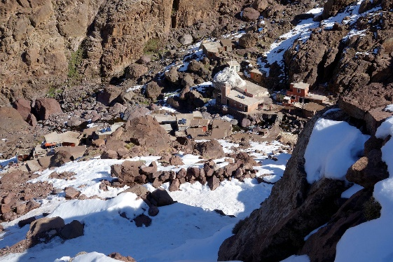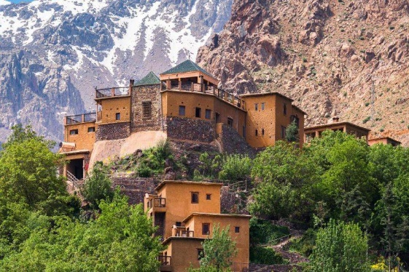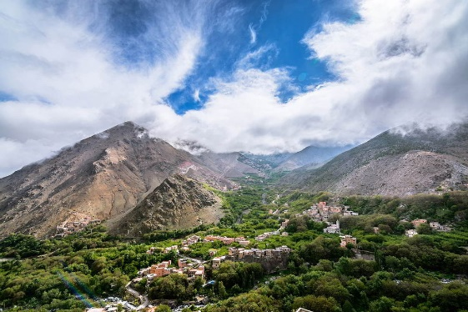

Private Excursion to Imlil – Discovering the High Atlas
Departure Time: 7:00 AM - Return Time: 7:00 PM (approx.)

Embark on an unforgettable day trip to Imlil, a picturesque village nestled at the foot of the majestic Mount Toubkal in the High Atlas Mountains. This private excursion is perfect for nature lovers, adventure seekers, and those who wish to discover the rich Berber culture. Enjoy a unique journey through breathtaking mountain landscapes and an authentic immersion into local life.

Day Itinerary :

7:00 AM - Private pickup from Riad Lallabaya
Your adventure begins with a private pickup directly from Riad Lallabaya. Along the way, admire the breathtaking views of the mountains, valleys, and traditional Berber villages.

9:30 AM - First stop in Asni
After about 1.5 hours of driving, we’ll stop in Asni, a typical village in the Ourika Valley. Take time to relax, capture memorable photos, and enjoy the peaceful mountain atmosphere. If you’re lucky, you may catch the weekly local market (souks), rich with fresh produce and artisanal crafts.

11:00 AM - Arrival in Imlil
We will continue to Imlil, a hidden gem in the heart of the mountains. Upon arrival, a local Berber guide (optional) will welcome you and guide you through an exploration of the village. Discover its charming cobblestone streets, traditional houses, and the warm hospitality of the locals.

11:30 AM - Hike through Imlil’s scenic valleys
Set out on a hike through Imlil’s enchanting landscapes. This 2 to 3-hour hike takes you through lush forests, terraced fields, and offers exceptional views of Mount Toubkal. Along the way, your guide will share fascinating stories about Berber culture and the region’s ecosystem.

1:30 PM - Traditional Berber lunch in a local home (not included)
After the hike, savor a traditional lunch at a Berber guest house. This meal, to be paid for on-site, includes authentic tagine, couscous, Moroccan salad, homemade bread, and fresh fruits. This culinary experience in an intimate setting will immerse you in Berber hospitality.

3:00 PM - Free time to explore Imlil
After lunch, enjoy free time to explore the village at your own pace. You can stroll through the streets, shop for artisanal souvenirs, or simply relax in this peaceful setting. For an adventurous touch, opt for a mule ride to further discover the surroundings.

4:00 PM - Return to Marrakech
6:00 PM - Arrival at Riad Lallabaya

Highlights of the Excursion:

- A private experience with dedicated transport from Riad Lallabaya
- Immersion in Berber culture, with the option of hiring a private guide (optional).
- A scenic hike through Imlil’s picturesque valleys with unforgettable views of Mount Toubkal.
- A traditional Berber lunch in an authentic setting (not included)
- Free time to explore or opt for a unique experience, such as a mule ride.

Practical Information:

- Price per person: Please refer to the price list
- Included transport : Pickup and return to Riad Lallabaya in a private air-conditioned vehicle.
- Guide (optional 250 mad) : A guide can be arranged at an additional cost.
- What to bring: Comfortable walking shoes, warm clothing it can get very cold in the mountains, a hat, sunscreen, and a camera.
- Lunch and tips are not included in the price and must be paid for directly on-site.

Book your private excursion now and enjoy a personalized journey to one of Morocco’s most beautiful and remote regions!

ZAGORA DESERT EXCURSION – 2 DAYS / 1 NIGHT

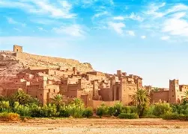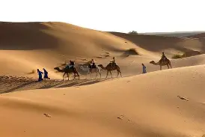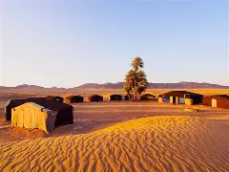

Private excursion to Zagora – At the gateway of the desert
Departure time: 7:00 AM (Day 1) Return time: 6:00 PM (Day 2, approx.)

Escape to the desert on a two-day private journey to Zagora.
This experience takes you through the breathtaking landscapes of southern Morocco, from the High Atlas Mountains to the lush Draa Valley and the first dunes of the desert.
An unforgettable experience combining discovery, authenticity, and a night under the stars.

Day itinerary:
Day 1

7:00 AM – Private pick-up at Riad Lallabaya
Departure towards southern Morocco. Cross the High Atlas Mountains via the Tizi N’Tichka Pass and enjoy ever-changing landscapes.

10:00 AM – Stop at Tizi N’Tichka Pass
Photo stop with panoramic mountain views.

12:30 PM – Lunch in Aït Ben Haddou (not included)
Visit the UNESCO-listed kasbah. Optional local guide available.

2:30 PM – Drive through the Draa Valley
Continue towards Zagora via Ouarzazate and the stunning Draa Valley, famous for its palm groves and traditional villages.

5:30 PM – Arrival in Zagora
Welcome at your desert camp.

6:00 PM – Camel ride (optional)
Enjoy a camel ride at sunset in the desert.

8:00 PM – Dinner & evening at the camp
Traditional Moroccan dinner followed by a convivial evening under the stars with local music.

Overnight in desert camp

Day 2
8:00 AM – Breakfast at the camp
Wake up in the peaceful desert atmosphere.

9:00 AM – Return to Marrakech
Departure back via the Draa Valley and Ouarzazate.

1:00 PM – Lunch stop (not included)

6:00 PM – Arrival at Riad Lallabaya

Excursion highlights:
• Private experience with dedicated transport from Riad Lallabaya
• Crossing of the High Atlas Mountains and Tizi N’Tichka Pass
• Discovery of Aït Ben Haddou (UNESCO site)
• Passage through Ouarzazate
• Drive through the Draa Valley
• Arrival at Zagora, at the gateway of the desert
• Overnight desert experience

Practical information:
• Price : : Please refer to the price list
• Transport included: Private air-conditioned vehicle with pick-up and drop-off at Riad Lallabaya
• Accommodation not included: Overnight in desert camp with dinner and breakfast
• Guide (optional): Available at an additional cost
• What to bring: Comfortable clothes, jacket for the evening, sunglasses, sunscreen
• Lunches diner accomodation and tips are not included and must be paid on site

MERZOUGA DESERT EXCURSION – 3 DAYS / 2 NIGHTS

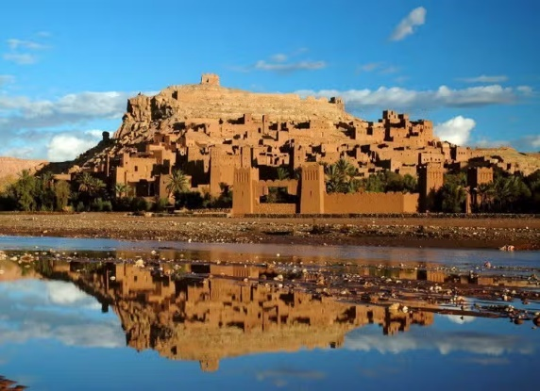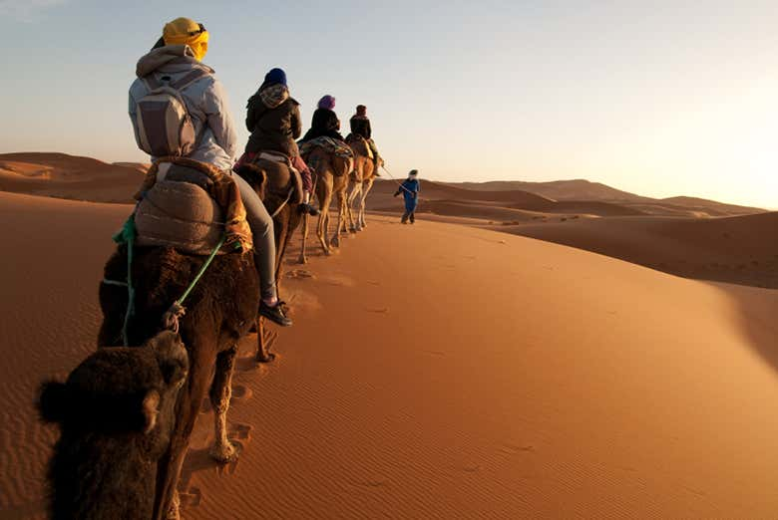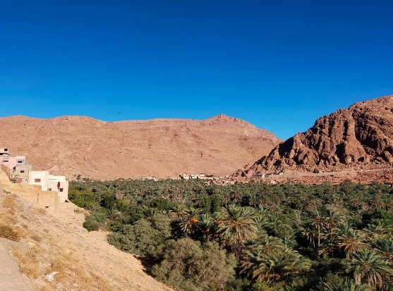

Private excursion to Merzouga – Sahara desert experience
Departure time: 7:00 (Day 1) Return time: 19:00 (Day 3, approx.)

Set off on an unforgettable journey to the Merzouga desert, at the gateway of the Sahara.
This private three-day experience takes you through some of the most spectacular landscapes in southern Morocco, from the Atlas Mountains to valleys, kasbahs, and golden dunes.
A unique experience combining discovery, scenery, and a deep change of atmosphere.

Itinerary:

Day 1

7:00 - Private pick-up at Riad Lallabaya
Departure towards southern Morocco. Cross the High Atlas Mountains via the Tizi N’Tichka Pass, with breathtaking views along the way.

10:00 - Stop at Tizi N’Tichka Pass
Photo stop to enjoy panoramic mountain views.

12:30 - Lunch in Aït Ben Haddou (not included)
Discover the famous UNESCO-listed kasbah. Optional guided visit available.

14:30 - Drive to Ouarzazate and the Dades Valley
Continue through Ouarzazate and towards the Dades Valley, known for its dramatic landscapes.

18:30 - Arrival in the Dades Valley
Check-in at the hotel (not included).

Day 2

8:00 - Breakfast at the hotel (not included)

9:00 - Departure to Merzouga
Drive through the Todra Gorges, known for their impressive cliffs, then continue towards desert landscapes.

13:00 - Lunch on the way (not included)

16:30 - Arrival in Merzouga
Arrival at the gateway of the desert and discovery of the dunes.

17:30 - Camel ride (optional)
Cross the dunes at sunset.
Check-in at the desert camp (not included)

Day 3

8:00 - Breakfast (not included)

9:00 - Return to Marrakech
Departure back to Marrakech through the southern landscapes.

13:00 - Lunch on the way (not included)

19:00 - Arrival at Riad Lallabaya

Key highlights:
• Private experience with dedicated transport
• Crossing of the High Atlas Mountains and Tizi N’Tichka Pass
• Visit of Aït Ben Haddou (UNESCO site)
• Passage through Ouarzazate and the Dades Valley
• Discovery of the Todra Gorges
• Arrival at the dunes of Merzouga, at the gateway of the Sahara
• Optional camel ride at sunset
• Immersion in the desert landscapes of southern Morocco

Practical information:
• Price per person: Please refer to the price list
• Transport included: Private air-conditioned vehicle with driver
• Accommodation: Not included (can be arranged on request)
• Meals: Not included
• Guide (optional): A local guide can be arranged
• What to bring: Comfortable clothes, jacket for the evening, sunglasses, sunscreen
• All meals, accommodation, drinks, and tips are at the clients’ expense and to be paid on site

OURIKA VALLEY– DAY PASS
DAR IMIRI

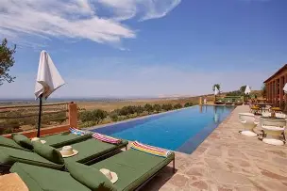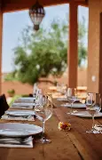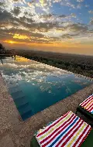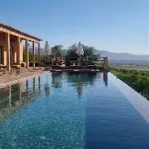

Dar Imiri - Partner Guesthouse
Departure time: 10:00 Return time: 18:45 (approx.)

Step away from Marrakech for the day and escape to the calm of the Ourika Valley, just 45 minutes away.
Dar Imiri is a hidden guesthouse set in nature, facing the Atlas Mountains. From the moment you arrive, everything slows down — open views, fresh air, and a peaceful atmosphere that feels far from the city.
This experience is designed as a full day to unwind, enjoy the setting, and experience a different side of Marrakech, more natural, more relaxed, and more intimate.

Key highlights:

• A beautiful natural setting, surrounded by mountains
• A calm and peaceful atmosphere, perfect to disconnect
• An infinity pool with wide views over the valley
• A proper lunch experience on site, served in a green, peaceful setting facing the mountains
• Comfortable spaces designed to relax and enjoy the moment
• A genuine experience, away from crowded places
• A day designed to step away from Marrakech and enjoy the Ourika Valley at a slower, more relaxed pace
• A guided exploration of the Ourika Valley and its landscapes

Guests often describe it as a place where you immediately feel at ease, with a warm atmosphere and attentive service.

09:00 - Private pick-up at Riad Lallabaya

09:30 - Guided walk through the souks
Discovery of local markets and traditional crafts.
11:00 - Visit of a Berber house & argan cooperative (Ourika Valley)
Insight into Berber lifestyle and local argan production.
12:30 - Setti Fatma waterfalls (Ourika Valley)
Arrival in the village of Setti Fatma, located at the end of the Ourika Valley.
Short guided walk (approx. 30–45 minutes) to reach the first of the famous Seven Waterfalls, following a path along the river with rocks, small bridges, and mountain views.
14:30 - Lunch on site (included)
A fresh Moroccan lunch served in a green, peaceful setting facing the mountains.
15:30 - Pool access & relaxation
Settle in and enjoy the pool, the sun, and the quiet surroundings.
16:30 - Free time
Last moments to relax before heading back.

18:30 - Return to Riad Lallabaya

Practical information:
• Price per person: Please refer to the price list
• Transport included: Private air-conditioned vehicle with driver
• Duration: Full day
• What to bring: Swimwear, sunglasses, sunscreen

Option: Extend your experience
For those who wish to stay longer, it is possible to spend the night at Dar Imiri (on request and subject to availability).
Enjoy a beautiful sunset over the Atlas Mountains, followed by a quiet evening in nature

MARRAKECH GUIDED TOUR – HALF DAY

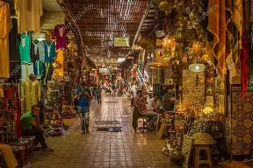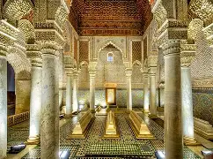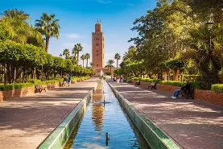
Private Medina Tour – History & Souks
Departure time: 9:00 or 14:00 - Duration: approx. 3 to 4 hours

Discover Marrakech through an immersive guided tour in the heart of the Medina, a UNESCO World Heritage site.
Accompanied by your local guide, explore the lively streets, traditional souks, and key historical sites for a complete introduction to the Red City.

Itinerary:
9:00 / 14:00 – Departure on foot from Riad Lallabaya with your guide

Saadian Tombs (depending on the route)
Explore this historic 16th-century site.

Koutoubia Mosque (outside visit)
Discover Marrakech’s iconic landmark and its famous minaret.

Jemaa el-Fna Square
Discover the vibrant heart of Marrakech.

Medina & souks
Walk through the narrow streets, traditional markets, and artisan workshops.

Bahia Palace
Visit this remarkable palace known for its architecture and gardens.

Key highlights:
• Private guided tour of the Medina
• Discovery of Koutoubia, Bahia Palace, and Saadian Tombs
• Exploration of the souks and local craftsmanship
• Immersion in Jemaa el-Fna Square
• Insight into Marrakech’s history and culture

Practical information:
• Price per person: see price list
• Guide: included (private local guide)
• Visit: on foot from Riad Lallabaya / Medina
• Transport: not included (can be arranged on request)
• Monument entrance fees: not included, to be paid on site
• What to bring: comfortable shoes, hat, sunglasses, sunscreen

MARRAKECH GUIDED TOUR – FULL DAY

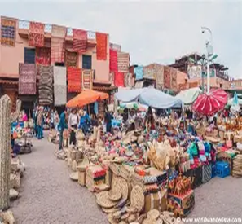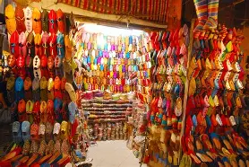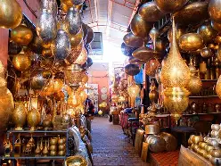
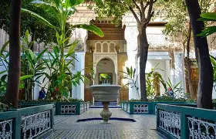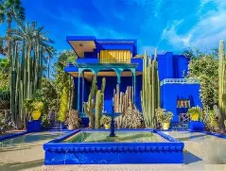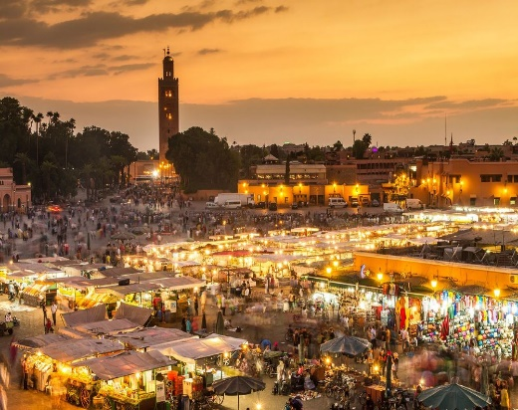

Private Marrakech Tour – Medina, Monuments & Districts
Departure time: 9:00-Return time: 17:30 (approx.)

Explore Marrakech in depth through a full-day guided tour combining heritage, souks, and different areas of the city.
This experience offers a complete overview of Marrakech, blending history, culture, and local atmosphere.

Itinerary:
9:00 – Departure on foot from Riad Lallabaya with your guide

Saadian Tombs
Explore this iconic historical site.

Bahia Palace
Visit one of Marrakech’s most beautiful palaces.

Koutoubia Mosque (outside visit)
Discover the city’s main landmark.

Medina & souks
In-depth exploration of the markets and narrow streets.

Free lunch (not included)

Free time / optional extension
Possibility to add a visit (Majorelle Garden or other, transport required).
17:30 – Return to Riad Lallabaya

Key highlights:
• Private full-day guided tour
• Discovery of the Medina, souks, and historical monuments
• Visit of Koutoubia, Bahia Palace, and Saadian Tombs
• In-depth exploration of Marrakech
• Flexible experience based on your preferences

Practical information:
• Price per person: see price list
• Guide: included (private local guide)
• Visit: on foot
• Transport: not included (can be arranged on request)
• Monument entrance fees: not included, to be paid on site
• Lunch: not included
• What to bring: comfortable shoes, hat, sunglasses, sunscreen

HOT AIR BALLOON – SUNRISE EXPERIENCE

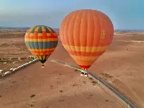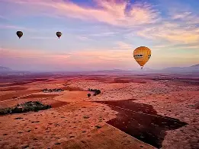

Exclusive experience – Sunrise hot air balloon flight
Departure time: between 5:00 and 6:00 (depending on the season) - Return time: 10:30 (approx.)

Enjoy a unique experience at sunrise, flying over the landscapes surrounding Marrakech.
Taking off from the desert plains just outside the city, this peaceful moment in the air offers breathtaking views over Berber villages, palm groves, and, on clear days, the Atlas Mountains.
A calm and unforgettable experience, guided by light, silence, and a true sense of freedom.

Experience schedule:

05:00 – Private pick-up at Riad Lallabaya
Comfortable transfer by private vehicle to the launch area (approx. 30 to 45 minutes).

Arrival & preparation
Welcome tea/coffee while the balloons are being prepared.

Hot air balloon flight (approx. 45 to 60 minutes)
Enjoy a sunrise flight in a small group, with a maximum of 16 guests per balloon, offering a more intimate and comfortable experience.

Landing & convivial moment
After landing, enjoy a relaxed moment in a traditional setting.

Berber breakfast
Served after the flight in a local atmosphere.

Return to Marrakech by private vehicle
10:30 – Arrival at Riad Lallabaya

Key highlights:
• Sunrise hot air balloon flight
• Private round-trip transfer from Riad Lallabaya
• Maximum 16 guests per balloon
• Panoramic views over the landscapes around Marrakech
• Discovery of Berber villages and desert plains
• Traditional breakfast after the flight
• A peaceful and timeless experience

Practical information:
• Price per person: see price list
• Transport: included (private vehicle)
• Total duration: approx. 4 to 5 hours
• Flight duration: approx. 45 to 60 minutes depending on weather conditions
• Weather conditions: the flight may be postponed for safety reasons. If rescheduling is not possible, a full refund will be provided.
• What to bring: comfortable clothing, light jacket, sunglasses

